Association, Composition and Aggregation in Java

Association is a relation between two separate classes which establishes through their Objects. Association can be one-to-one, one-to-many, many-to-one, many-to-many. In Object-Oriented programming, an Object communicates to another object to use functionality and services provided by that object. Composition and Aggregation are the two forms of association.

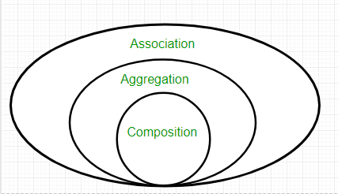

class Bank {

// Attributes of bank
private String name;

private Set<Employee> employees;
………..

In the above example, two separate classes Bank and Employee are associated through their Objects. Bank can have many employees, So it is a one-to-many relationship.
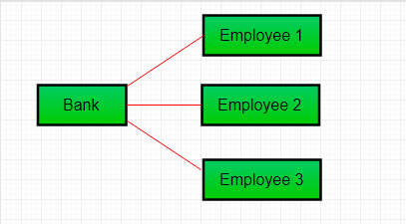

Aggregation

It is a special form of Association where:
- It represents Has-A’s relationship.
- It is a unidirectional association i.e. a one-way relationship. For example, a department can have students but vice versa is not possible and thus unidirectional in nature.
- In Aggregation, both entries can survive individually which means ending one entity will not affect the other entity.

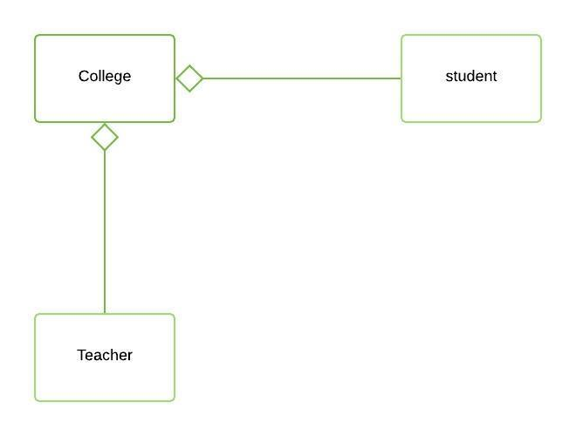

Composition

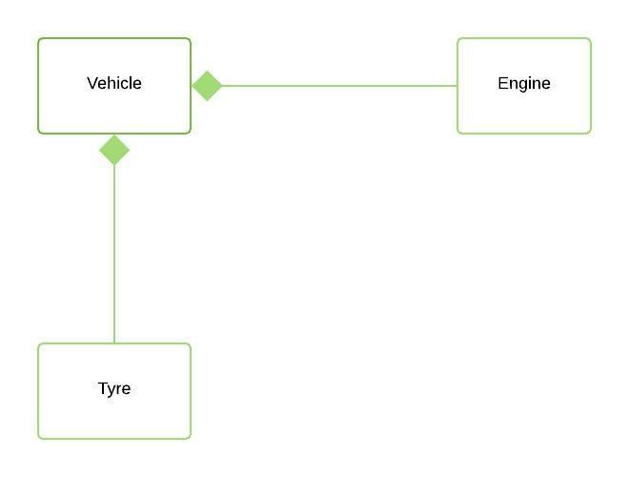

Composition is a restricted form of Aggregation in which two entities are highly dependent on each other.
- It represents part-of relationship.
- In composition, both entities are dependent on each other.
- When there is a composition between two entities, the composed object cannot exist without the other entity.

Aggregation vs Composition
1. Dependency: Aggregation implies a relationship where the child can exist independently of the parent. For example, Bank and Employee, delete the Bank and the Employee still exist. whereas Composition implies a relationship where the child cannot exist independent of the parent. Example: Human and heart, heart don’t exist separate to a Human
2. Type of Relationship: Aggregation relation is “has-a” and composition is “part-of” relation.
3. Type of association: Composition is a strong Association whereas Aggregation is a weak Association.

